**Project 7-1: Creating a Virtual Machine from a Physical Computer**

The VMware vCenter Converter creates a virtual machine from an existing physical computer.

In this project, you download and install vCenter to create a virtual machine.

1. Use your web browser to go to www.vmware.com. (The location of content on the

Internet may change without warning. If you are no longer able to access the program

through this URL, use a search engine to search for “VMware”.)

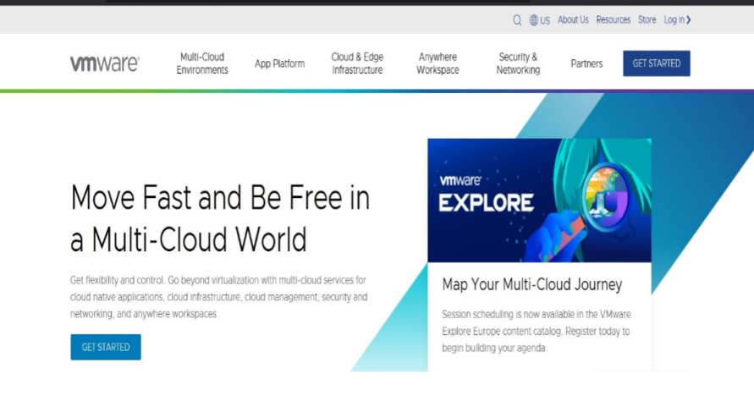

2. Click Downloads.

3. Click vCenter Converter.

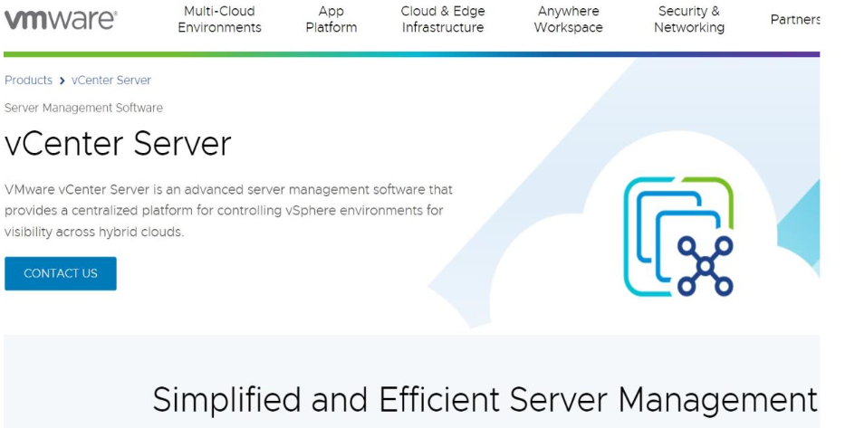

4. If necessary, click Create an account, enter the requested information, and log into

VMware.

5. If necessary, accept the terms of use and click I agree.

6. Click Manually Download.

7. When the download completes, run the installation program to install vCenter by

accepting the default settings.

8. Launch vCenter to display the VMware vCenter Converter Standalone menu.

9. Click Convert machine.

10. Under Select source type, choose This local machine. Click Next.

11. Next to Select destination type:, choose VMware Workstation or other VMware

virtual machine.

12. Under Select a location for the virtual machine:, click Browse.

13. Navigate to a location to store the new virtual machine. Click Next and then click Next

Again.

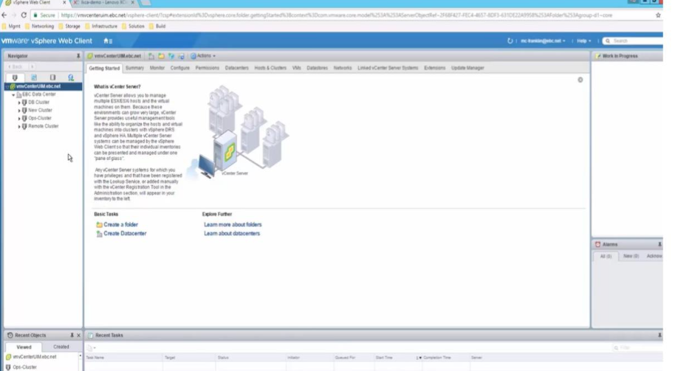

14. Click Finish to create the virtual machine from the physical machine.

15. When the vCenter has finished, note the location of the image, which will be one or

more *.vmx and *.vmdk files in the destination folder. It will be used in the next project.

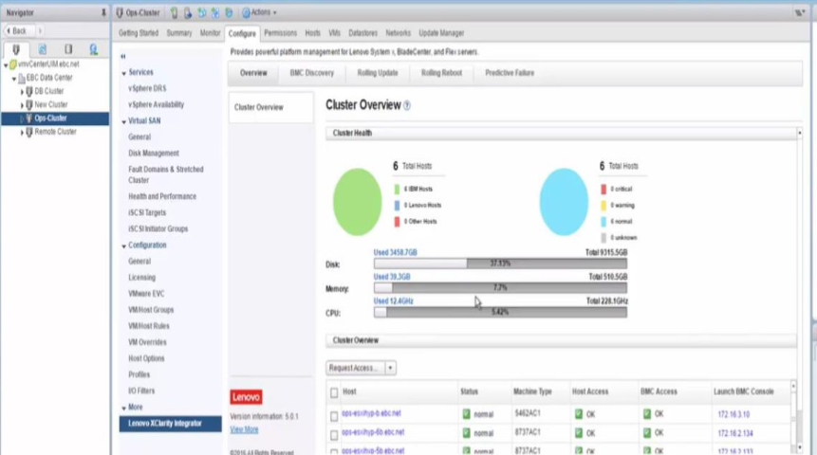

16. Close all windows.

**Project 7-2: Loading the Virtual Machine**

In this project, you download a program to load the virtual machine created in Project 7-1.

1. Use your web browser to go to my.vmware.com. (The location of content on the

Internet may change without warning. If you are no longer able to access the program

through this URL, use a search engine to search for “VMware Workstation”.)

2. Click All Downloads.

3. Click View Download Components.

4. Select the Workstation Player for your computer’s operating system. Click Download.

5. When the download completes, launch the installation program to install VMware

Workstation Player.

6. Start VMware Workstation Player after the installation completes.

7. Click Open a Virtual Machine.

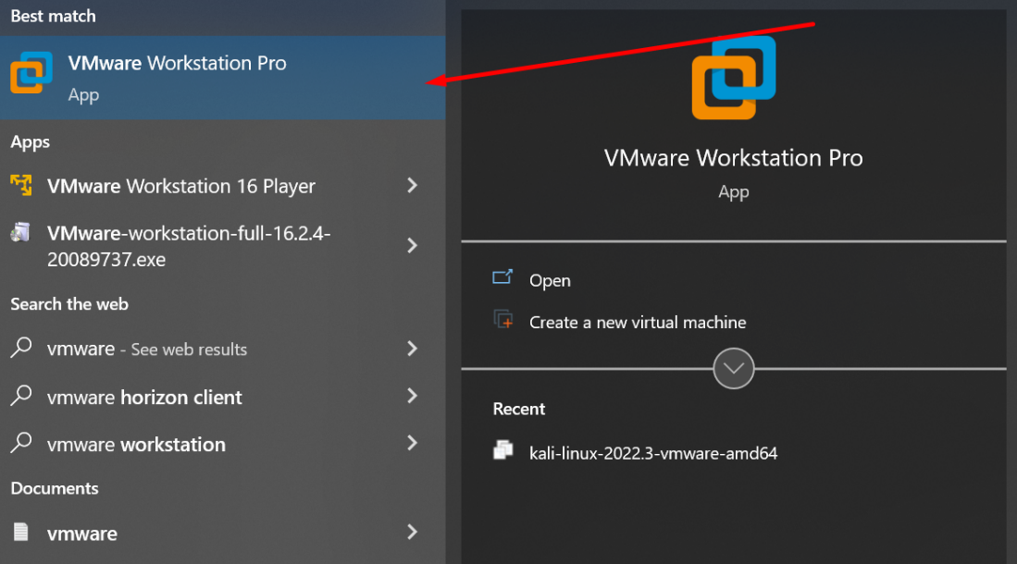

8. Navigate to the location of the virtual machine that you created in Project 7-1. Click

Open.

9. Click Edit virtual machine settings. Note the different options for configuring the

hardware of the virtual machine. Click through these options and if desired change any

of the settings. Click Close.

10. How easy was it to create a virtual machine from a physical machine?

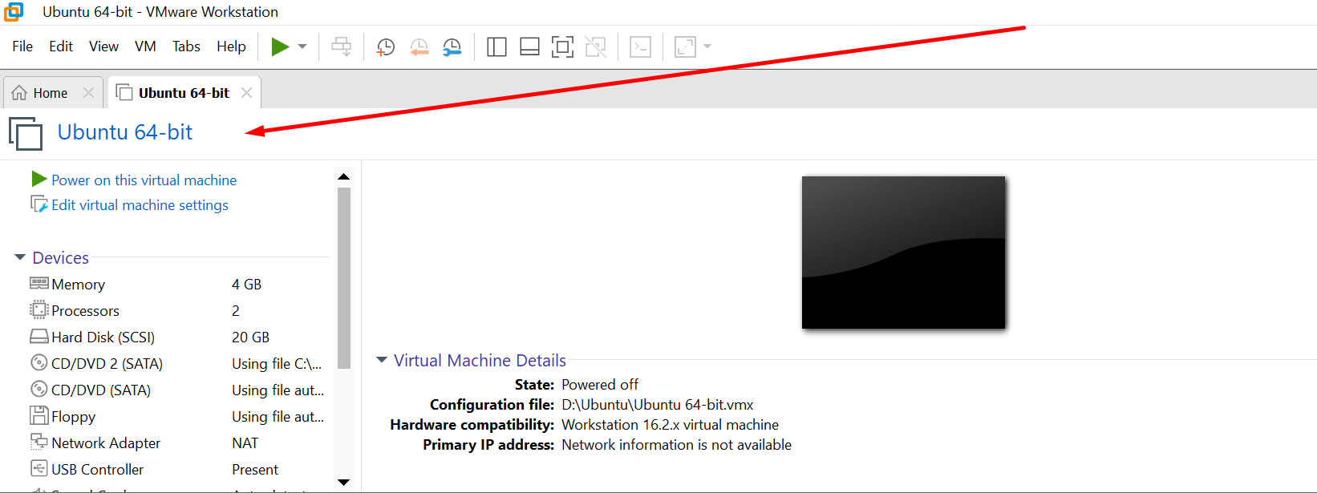

11. Close all windows.

**Project 7-3: Viewing SNMP Management Information Base (MIB) Elements**

SNMP information is stored in a management information base (MIB), which is a database for

different objects. In this project, you view MIBs.

1. Use your web browser to go to www.mibdepot.com. (The location of content on the

Internet may change without warning. If you are no longer able to access the program

through this URL, use a search engine to search for “MIB Depot”.)

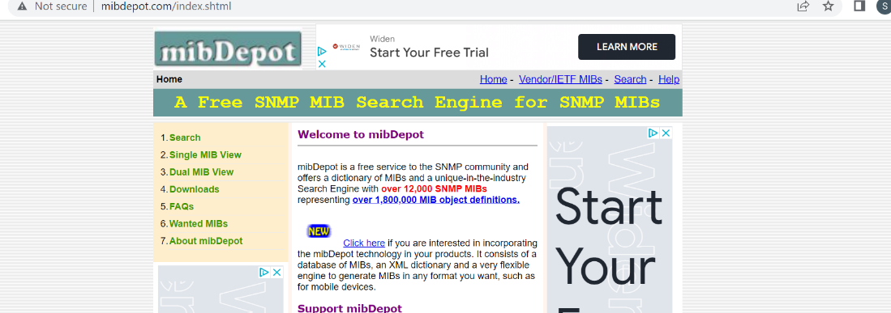

2. In the left pane, click Single MIB View.

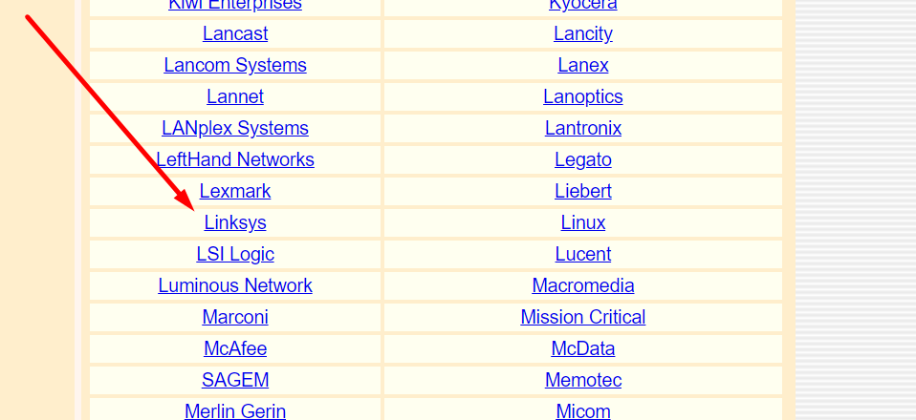

3. Scroll down and click Linksys in the right pane. This will display the Linksys MIBs

summary information.

4. In the left pane, click v1 & 2 MIBs to select the SNMP Version 1 and Version 2 MIBs.

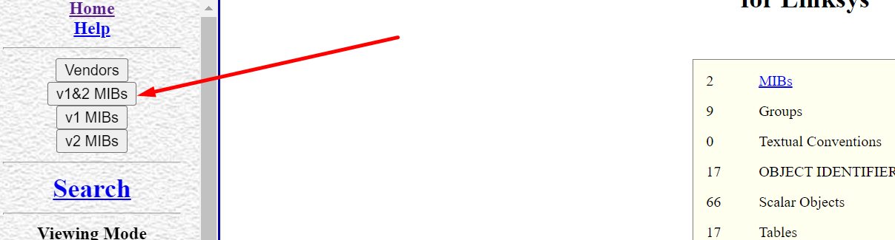

5. In the right pane, click LINKSYS-MIB under MIB Name (File Name). This will display a

list of the Linksys MIBs

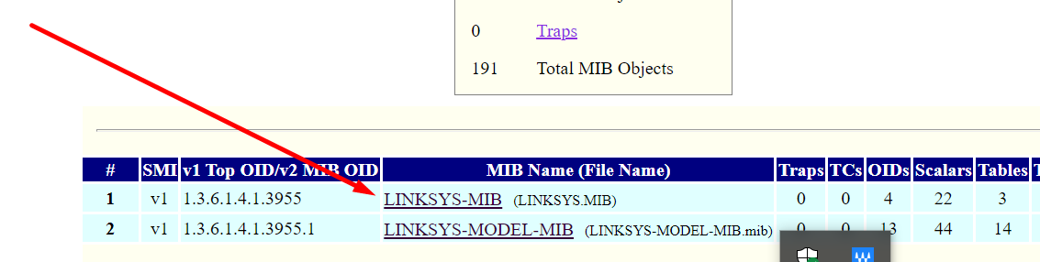

6. Click Tree under Viewing Mode in the left pane. The MIBs are now categorized by Object

Identifier (OID). Each object in a MIB file has an OID associated with it, which is a series of

numbers separated by dots that represent where on the MIB “tree” the object is located.

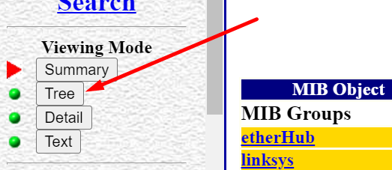

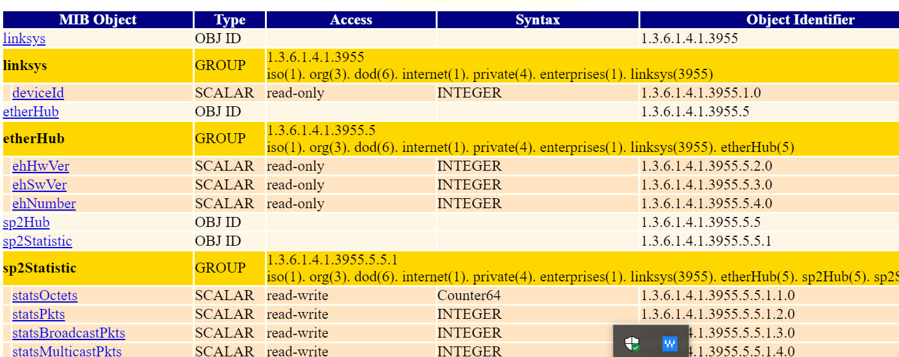

7. Click Text in the left pane to display textual information about the Linksys MIBs.

Scroll through the Linksys MIBs and read several of the descriptions. How could this

information be useful in troubleshooting?

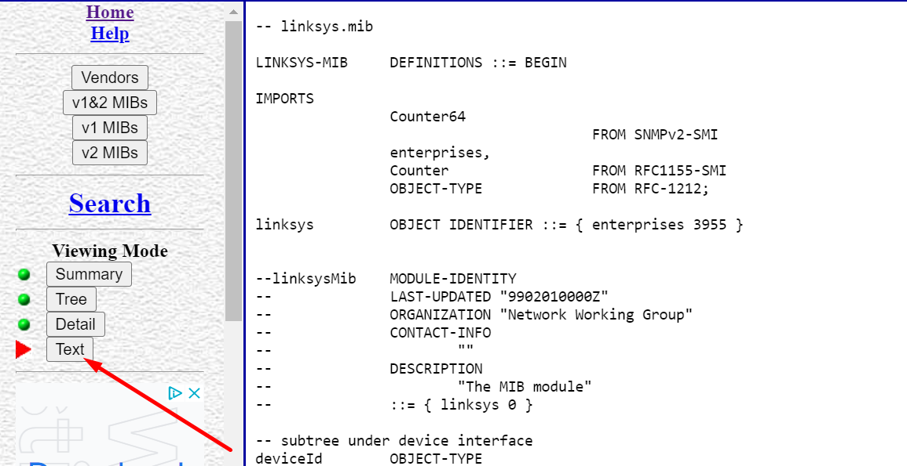

This information can be useful as we can know where the problem is and we will not be confused as we can see where the problem is coming from and which part should be updated without hampering all the components.

8. Now look at the Cisco MIBs. Click Vendors in the left pane to return to a vendor list.

9. Scroll down and click Cisco Systems in the right pane. How many total Cisco MIB

objects are listed? Why is there a difference?

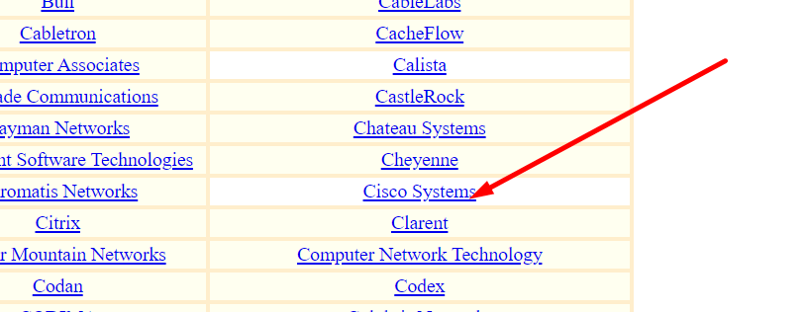



10. In the right pane, click the link Traps.

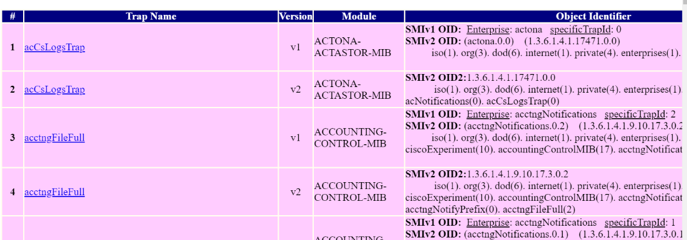

11. Scroll down to Trap 74, which begins the list of Cisco wireless traps. Notice the

descriptive names assigned to the wireless traps.

12. Now scroll down to Traps 142-143 and click the name bsnAPIfDown. Read the

description for this SNMP trap. When would it be invoked? Click the browser’s Back

arrow to return to the listing.

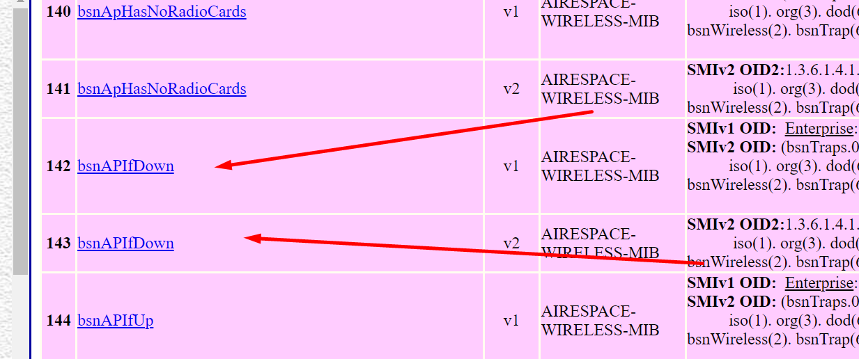

It is Enterprise Trap, and it will be invoked in the trap id 10 is called

13. Close all windows.

**Project 7-4: Viewing Logs Using the Microsoft Windows Event Viewer**

In this project, you view logs on a Microsoft Windows computer.

1. Launch Event Viewer by clicking Start and then type Administrative Tools in the Search

programs and files box.

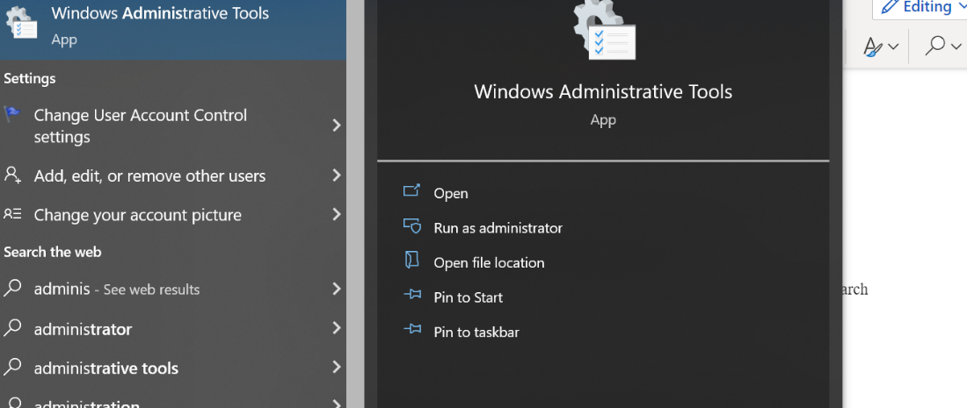

2. Click the Administrative Tools folder and then double-click Event Viewer.

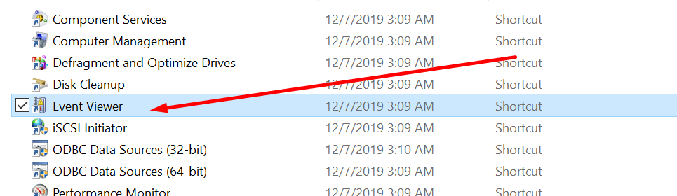

3. The Event Viewer opens to the Overview and Summary page that displays all events

from all Windows logs on the system. The total number of events for each type that

have occurred is displayed along with the number of events of each type that have

occurred over the last seven days, the last 24 hours, or the last hour. Click the > sign

under each type of event in the Summary of Administrative Events to view events that

have occurred on this system.

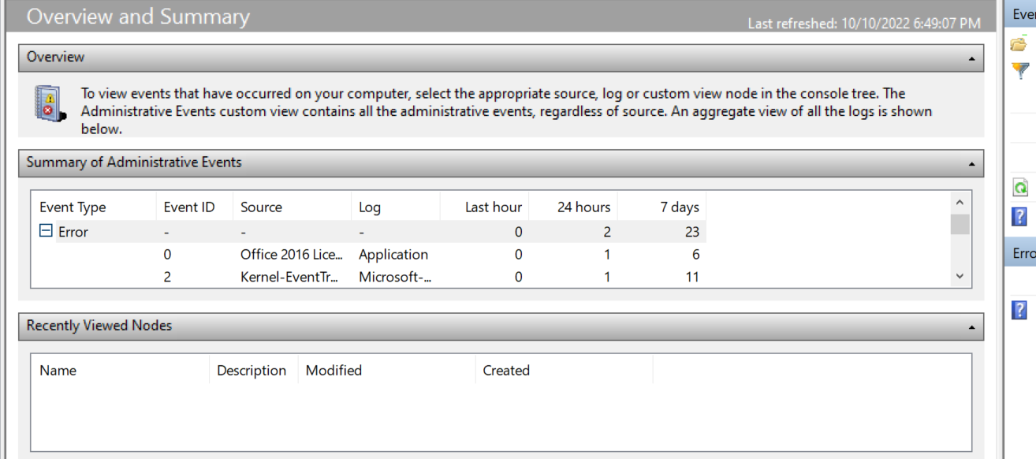

4. Select a specific event and then double-click it to display detailed information on the

event. Is this information in a format that a custodian could use when examining a

system? Is it in a format that an enduser would find helpful?

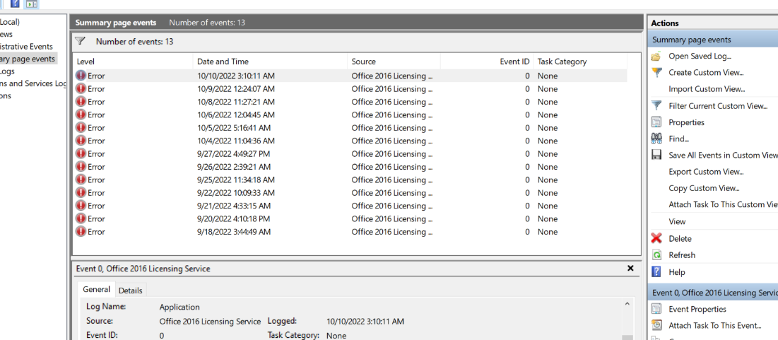

No, it is not in the format where it is helpful but it can be used to get some informations.

5. When finished, click the Back arrow to return to the Overview and Summary page.

6. In the left pane under Event Viewer (Local), double-click Windows Logs to display the

default generated logs, if necessary.

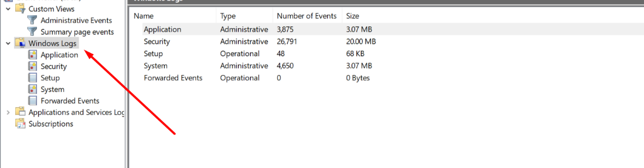

7. Double-click Security.

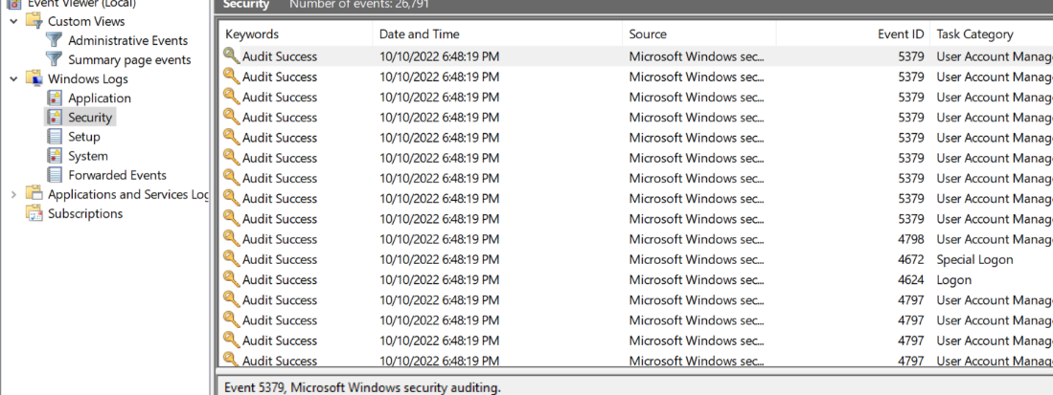

8. Select a specific event and then double-click it to display detailed information on the

event. When finished, click Close and the Back arrow to return to the Overview and

Summary page.

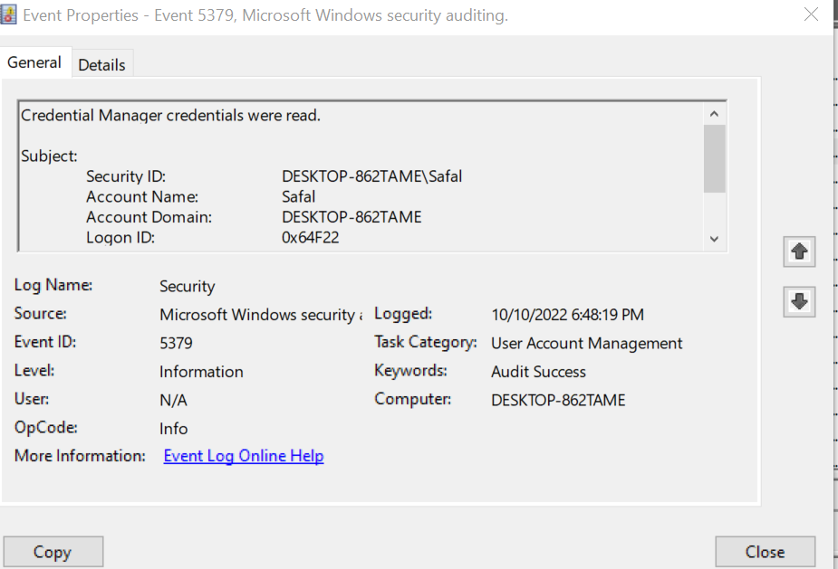

9. In the left pane under Event Viewer (Local), double-click Applications and Services

Logs to display the default generated logs, if necessary.

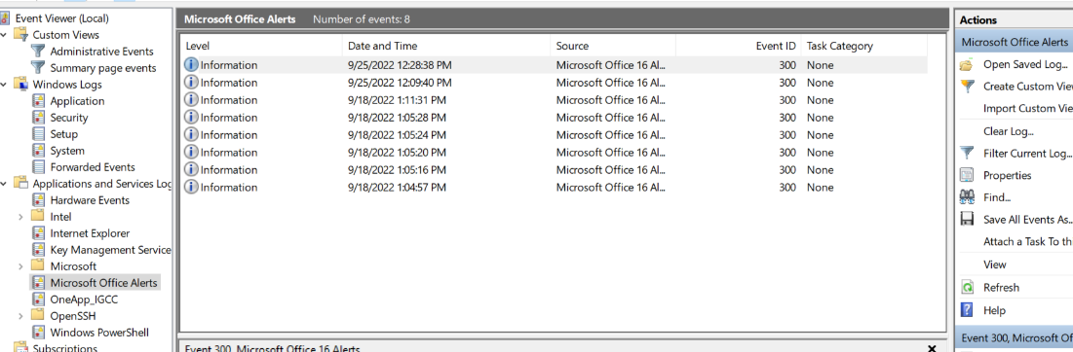

10. Select a specific event and double-click it to display detailed information on the event.

When finished, click Close and then double-click Event Viewer (Local) in the left pane.

Leave this window open for the next project.

**Project 7-5: Creating a Custom View in Microsoft Windows Event Viewer**

Microsoft Windows Event Viewer also can be used to create custom logs and collect copies of

events from different systems. In this project, you use the Event Viewer to create a custom log.

1. If necessary, launch Event Viewer by clicking Start and then typing Administrative

Tools in the Search programs and files box. Click the Administrative Tools folder and

then double-click Event Viewer.

2. In the right pane entitled Actions, click Create Custom View.

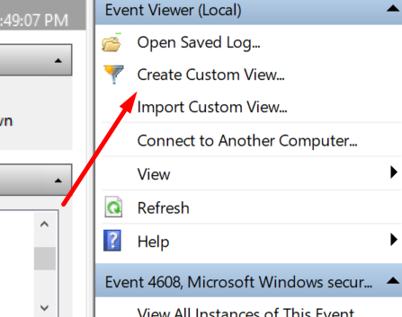

3. Under Logged click the drop-down arrow next to Any time. Several options appear

of times to log the events. Click Custom range and note that you can create a specific

period to log these events. Click Cancel and be sure the Logged setting is Any time to

capture all events.

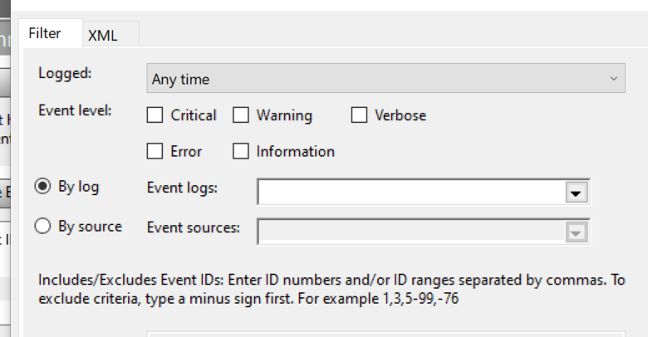

4. Under Event level, check each box (Critical, Error, Warning, Information, Verbose) to

capture all levels of events.

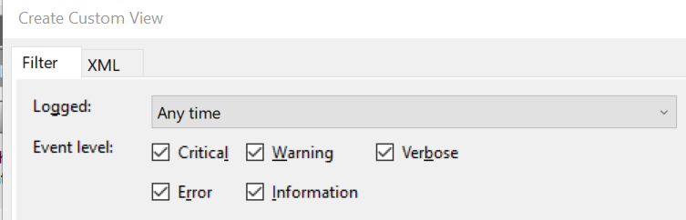

5. Under By source, click the radio button if necessary and then click the drop-down

arrow next to Event sources. Scroll through the list of sources that can be used to

create a log entry.

6. For this custom view, instead of selecting specific sources, you will use log entries

collected from default logs. Under By log, click the radio button if necessary and then

click the drop-down arrow next to Event logs.

7. Click the > sign by Windows Logs and Applications and Services Logs. Any of these

logs can be used as input into your custom logs. Click the box next to Windows Logs to

select all the available Windows logs.



8. You also can include or exclude specific events. Be sure that <All Event IDs> is selected.

9. Next to Keywords select Classic.

10. Next to User be sure that <All Users> is selected so that any user who logs in to this

system will have log entries created.

11. Your completed dialog box will look like that shown in Figure 7-11. Click OK. If an Event

Viewer dialog box appears, click Yes.

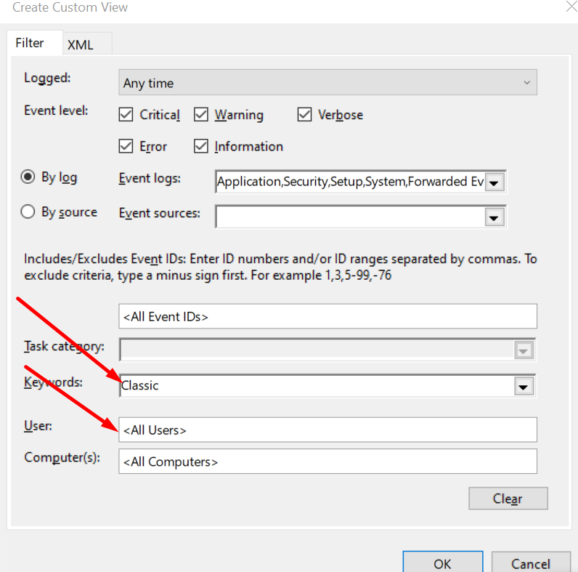

12. In the Save Filter to Custom View dialog box, next to Name, enter All Events.

13. Next to Description, enter All Events. Click OK.

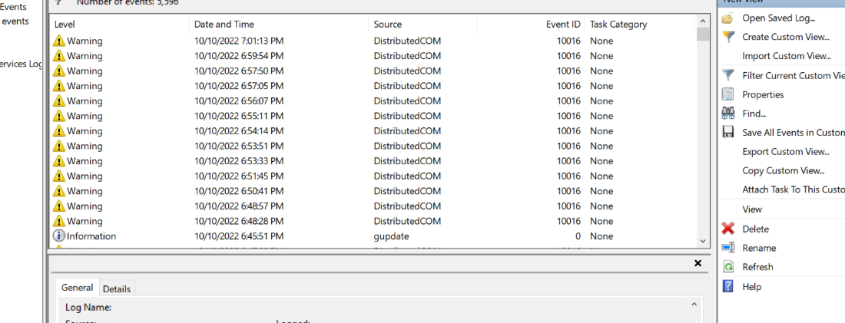

14. In the left pane under Event Viewer (Local), double-click Custom Views if necessary to

display the custom view. Display your view by clicking on it.

15. Close Event Viewer and all windows.

16. Reboot the system.

17. If necessary, launch Event Viewer by clicking Start and then typing Administrative

Tools in the Search programs and files box. Click the Administrative Tools folder and

then double-click Event Viewer.

18. In the left pane under Event Viewer (Local), double-click Custom Views if necessary

to display the custom views. Display your view by clicking it. What new events have

Occurred?

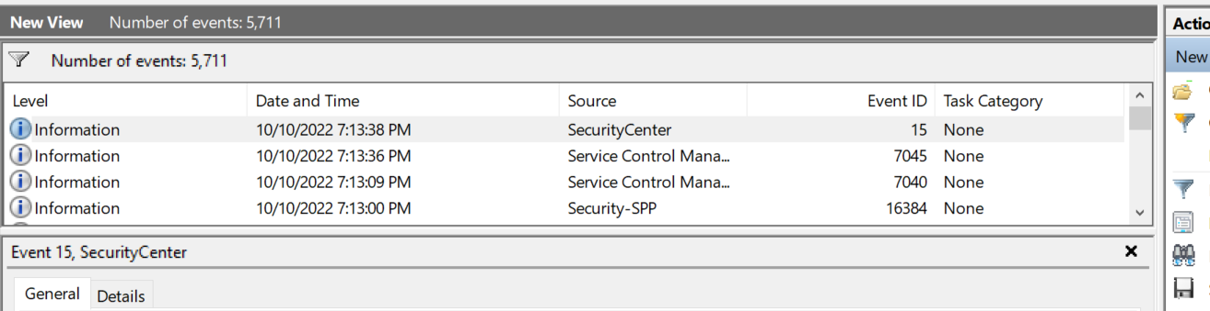

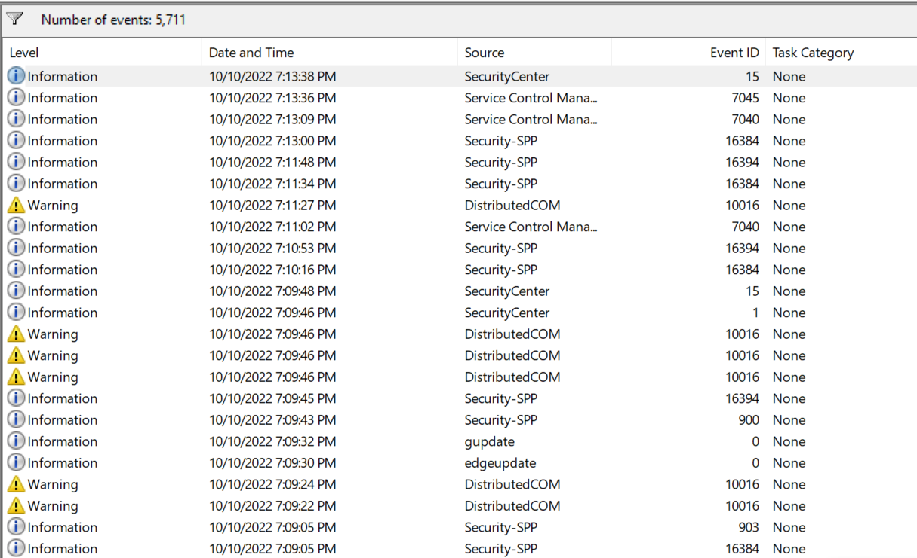

These are the new events that have occurred after rebooting .

19. Close all windows.

**Case Project 7-1: Software Defined Network (SDN)**

Use the Internet to research software defined network (SDN). How do they function? What are

their features? What are the advantages of each type? What are the disadvantages? Create a

table comparing SDNs with traditional networks. If you were to recommend a SDN for your

school or business, what would be the reason(s)?

A recently developed computer networking architecture is called "software-defined networking" (SDN). The separation of the data plane from the control plane in routers and switches is a key differentiator. In other words, the control is implemented in software and is uncoupled from the hardware. In this architecture, the data plane is implemented within networking gear or equipment, whereas the control plane is implemented via software within servers and is independent of networking hardware. OpenFlow is the ideal illustration of this design.

A switch sends a route request to a controller for a packet that lacks a specific route in software-defined networking's so-called adaptive or dynamic operating mode. Adaptive routing, which does not use a controller and instead provides route requests through routers and algorithms based on the network topology, is distinct from this method.

With SDN, the administrator has the flexibility to modify the rules of any network switch as needed, prioritizing, de-prioritizing, or even banning types of packets with a high degree of control. This is especially useful in a multi-tenant cloud computing architecture since it enables the administrator to control traffic loads more effectively and flexibly. In essence, this gives the administrator greater control over network traffic flow and enables the use of less expensive commodity switches.

Advantages:

* Centralized network provisioning:

It is simpler to centralize enterprise administration and provisioning with software-defined networks since they offer a consolidated view of the entire network. For instance, increasing numbers of VLANs are included into actual LANs, resulting in a Gordian knot of interconnections and links. SDN can speed up service delivery and offer more agility in provisioning both virtual and physical network devices from a central location by abstracting the control and data planes.

* Holistic enterprise management:

For enterprise networks to support new processing demands, such as those for big data, new applications and virtual machines must be put up instantly. SDN enables IT managers to test different network configurations without having an influence on the whole network. Unlike SNMP, SDN permits management of network devices, including switches, from a central controller, both physically and virtually. For the creation of a single administration console for both physical and virtual devices, SDN offers a single set of APIs.

* More granular security

Centralized security is one of the features of security defined networking that IT administrators find most appealing. Network administration has grown more difficult as a result of virtualization. Applying firewall and content filtering regulations consistently becomes increasingly challenging as virtual machines come and go as a component of physical systems. The security issue is made worse when complications like safeguarding BYOD devices are included.

Disadvantages:

* requires a change in the entire network infrastructure to implement SDN protocol and SDN controller. Therefore, the network must be completely reconfigured. These increases cost due to reconfiguration
* Staff need to be trained.
* New management tools need to be procured and everyone should be trained to use it.
* Security is a big challenge in SDN

**Case Project 7-2: Securing Email**

Use the Internet to research different options for encrypting and securing email. Create a

table that lists at least five options. Include the advantages and disadvantages of each. Which

would you recommend? Why? Write a one-paragraph explanation along with your table.

|  |  |  |
| --- | --- | --- |
| Encryption options | Features | Recommendation |
| Enterprise email encryption | Transparent for employees, easy to enforce policies | * For B 2 B emails and large business * Managing many employees |
| Secure webmail | Esay Setup/ low cost | * Independent professionals and businesses, who only send security to clients |
| Encyro | Allows clients to send encrypted messages or documents without creating an account. Low cost, business friendly | * Independent professionals and businesses, secure messages from/to clients |
| TLS | You don’t need to do anything, and it happens behind the scenes | * For anyone who can't use other options mentioned |
| DIY Encryption | You control keys and no organization is trusted here | * Good for those who want to learn DIY * People who are trying to avoid government surveillance |

As you donot have to worry about what happens behind the scence and it runs and has good security features, I would prefer TLS. Data exchanged between applications over the Internet is secured end-to-end using the cryptographic protocol TLS. In instance, the padlock icon that appears in web browsers when a secure session is started makes it most familiar to consumers when used in secure web browsing. However, it may and should also be used for other applications, including voice over IP, file transfers, video/audio conferencing, instant messaging, and voice over IP, as well as for Internet services like DNS and NTP. Without TLS, not only are surfing patterns, email communications, online chats, and conference calls susceptible to surveillance, but also sensitive information like logins, credit card numbers, and personal details. It makes sure that data transported between client and server apps is encrypted with secure algorithms and cannot be viewed by other parties by enabling client and server programs to support TLS.

Reference:

<https://blog.encyro.com/email-encryption-service-comparisons-for-your-business-in-2017/>

**Case Project 7-3: Comparing Cloud Computing Features**

As cloud computing increases in popularity, enhanced features are continually being added.

Compare Microsoft Azure with Amazon Web Services (AWS). Create a table that lists at least

five features. What are the advantages of each? What are the disadvantages? Which would

you recommend? Why? Write a one-page summary of your research.

|  |  |  |
| --- | --- | --- |
|  | Azure | AWS |
| Feature | Has a deeper range of features like PaaS and IaaS | It has a wider range of features but requires more management |
| Hybrid cloud | It has a strong heritage with hybrid environments. Has stack called Azure stack | Previous cloud first mentality. Backtracking and slow responding |
| Developers | Access to more global data centers to support infrastructure | Better willingness to integrate with third parties |
| Compliance | Claims to have more certifications than other providers | Strong relationship with global agencies but lacks enterprise experience |
| Getting started | Most experimented provider till now for beneficial free trials | Competitive and always decreasing pricing model |

Looking at the different features that AWS and Azure both have and are still developing, it is clear who appears to be meeting market demands the quickest. AWS entered the "cloud game" a few years earlier than Azure and has more than 4 times the income of Azure. The following graph, however, demonstrates how quickly Microsoft is catching up in terms of application workloads, particularly with relation to IaaS. Their history of working with enterprise platforms serves as the foundation for this job.

Amazon breaks out its cloud goods using various codes and names, just like other cloud providers do. Having stated that, they can be divided into the following groups: analytics, applications services, databases, and migration. Moving on to Microsoft Azure, they are also constructing an end-to-end infrastructure there in order to meet the demands of their clients. However, their history with industrial computing has greatly helped them when it comes to creating contemporary, wanted solutions. Creating enterprise agreements is a part of this. These make it possible for big businesses to profit from committing usage to Azure. These advantages include flexible billing and more affordable prices.

Both Azure and AWS are well-suited from a development standpoint to handle the high pressure demands of architects. It is merely a matter of measuring relevance because, as has been mentioned, each platform tends to have its own advantages and disadvantages. For instance, Service Fabric and Container Services are components of Azure that are excellent for developing, deploying, and scaling applications. As a result, Microsoft has grown to be a significant player in the IaaS market. Additionally, there are fewer options available for app hosting on AWS. But their plan may not give this a high priority. That being said, AWS has gained a significant portion of its market share by making it simple for companies of all kinds to transfer massive amounts of data to the cloud, which, despite being more basic, is highly beneficial.

Reference:

<https://www.hpe.com/us/en/services/redpixie-azure.html>

**Case Project 7-4: Centralized Device Log Analyzers**

Use the Internet to research four different centralized device log analyzers. Create a table

comparing their benefits, the platforms they support, their advantages and disadvantages,

and costs. Which would you recommend? Why?

|  |  |  |  |  |
| --- | --- | --- | --- | --- |
|  | Splunk | LogRhythm | Logentries | LogPacker |
| Advantages | Alerting and reporting are built-in. customizable dashboards and charts.  SaaS remedy. Scale up your system from one server to several data centers. Real-time analysis, visualization, and search | Real-time intelligent search. gathers information from all log sources, including databases and applications. 700 sources of logs. Monitoring in real-time and adaptable, role-based notifications. correlation with one click from any search. Users may easily correlate, search, and pivot through their data using the console. | intelligent search in real-time. pulls data from all log sources, including apps and databases. 70 logging sources. Real-time monitoring and flexible, role-based notifications. association with a single search-related click. The console allows users to effortlessly correlate, search, and pivot through their data. | More than 100 types of log sources are already supported natively. many storage companies. System for alerting and reporting through SMS, Slack, or Email. dependable clustering. Unix, Windows, mobile, and JS all have broad platform support. REST API to create unique solutions based on data saved. Aggregation of events and security. exemplary performance Cloud dashboard on disk |
| Disadvantages | Setting up and adding new sources is difficult. Each source needs to be individually inserted. 500 MB per day is insufficient to use it for free, whereas 1 GB per day costs 2.700 $ per year. | large initial outlay. Documentation and user guides are not transparent. | Manual installation and maintenance of log sources. The cause of errors in third-party libraries cannot be found. 100 logs are the maximum allowed per server. Web client logger that isn't properly secure. No specialized JavaScript reporting | There is no built-in web interface in the standalone version. In Clust, the free version is limited to 5 servers. |
| Benefits | Additionally, Splunk includes built-in reporting capabilities with sophisticated charts and dashboards, as well as a pivot interface for creating visual reports with ease. | In order to streamline not only log management but also loganalysis, event management, and reporting, LogRhythm combines both into a single, centralized platform. But LogRhythm also offers a network server agent that may be installed. | Agent-less and agent-based log gathering are two options provided by Logentries. When issues arise, Lo-gentries offers a live tail view that aggregates all of your logs so you can see what is happening in real time. New instances can be readily configured to send all log data in real-time to Logentries as your environment dynamically scale | The key benefit is that LogPacker can locate and send to the Cluster all collected and aggregated logs on the server and operates solely from the box. Every LogPacker service is written in Go and designed for speed. Typically, the basic server installation uses 30–40 MB of memory for the Agent instance. |

I would use Logentries because it is free, and the users can use up to 5 GB free so that you have plenty of storage to use it and test it out. In that time, you can always make sure that you like it and it is easy to use.

**Case Project 7-5: Cloud Computing Benefits**

Would your school or place of work benefit from cloud computing? Identify at least two cloud

computing vendors and research their features and costs. Then look at one element of your

school or work network infrastructure and apply it to cloud computing. Would it be feasible?

Why or why not? Write a one-page paper on your research and opinions.

Dropbox is a cloud storage service that gives customers the opportunity to transfer files in a synchronized style as well as store them on faraway cloud servers. Dropbox offers a cloud-based infrastructure as a service model-based online storage solution (IaaS). Users of Dropbox get access to free online storage for up to 2 gigabytes of material, including music and document files. Users can view these files from any device with an internet connection using your Dropbox account. In this sense, Dropbox is a small-scale examination of cloud computing.

Google Drive is a cloud computing and cloud storage hybrid. In addition to being incorporated into what was once known as Google Docs, Google Drive is comparable to services like Dropbox, SugarSync, and Trend Micro's SafeSync. As a result, Google Drive functions as both a cloud storage service and a cloud computing platform. Google Drive is your best choice for cloud storage if you own a Chromebook because it is integrated into Google's Web-based operating system Chromium. Drive includes iOS and Android apps for viewing and managing your files from your phone, just like other cloud storage providers.

Google Drive comes with 15GB of free storage by default, which is far larger than Dropbox's initial 2GB of free storage. Even while Dropbox offers that option, Google Drive's free storage is ultimately superior. Both Dropbox and Google's cloud services are already effectively used by Busy Bee Tutoring. Tutors can share files and stay current on the most recent SMART Goals and other reports thanks to these IaaS services. The tutors can all stay up to date on criteria because of the accessibility and real-time updating.

**3. Encrypted Assignment**

Download gpg4win

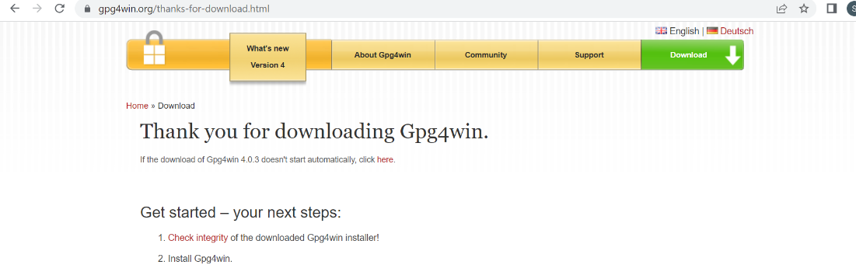



* Install the software

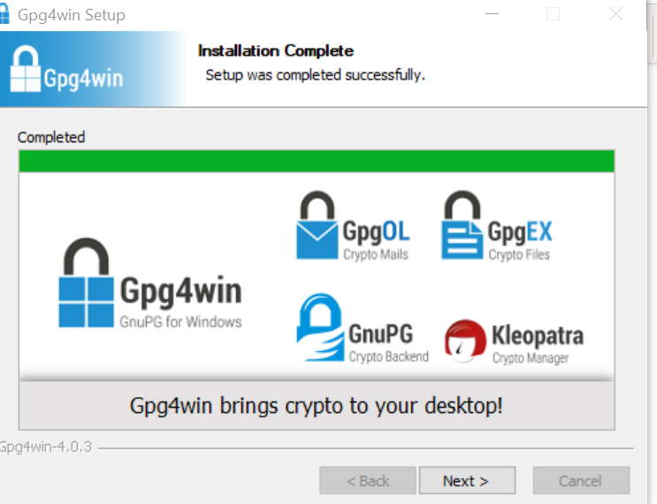

Generate the key pair

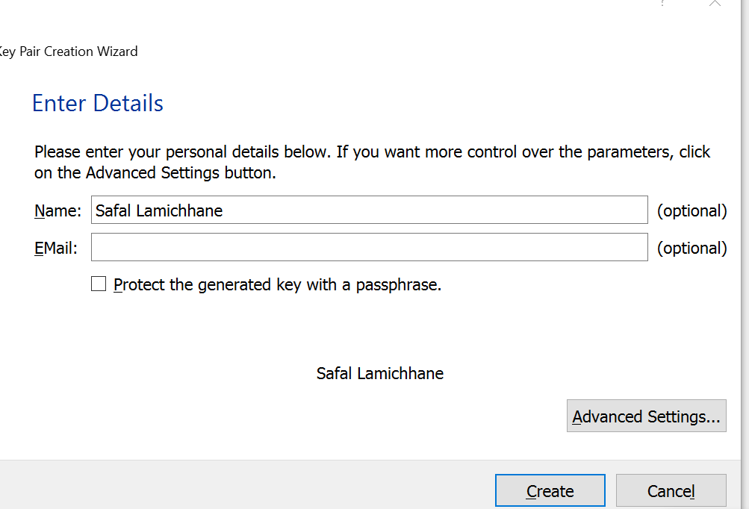

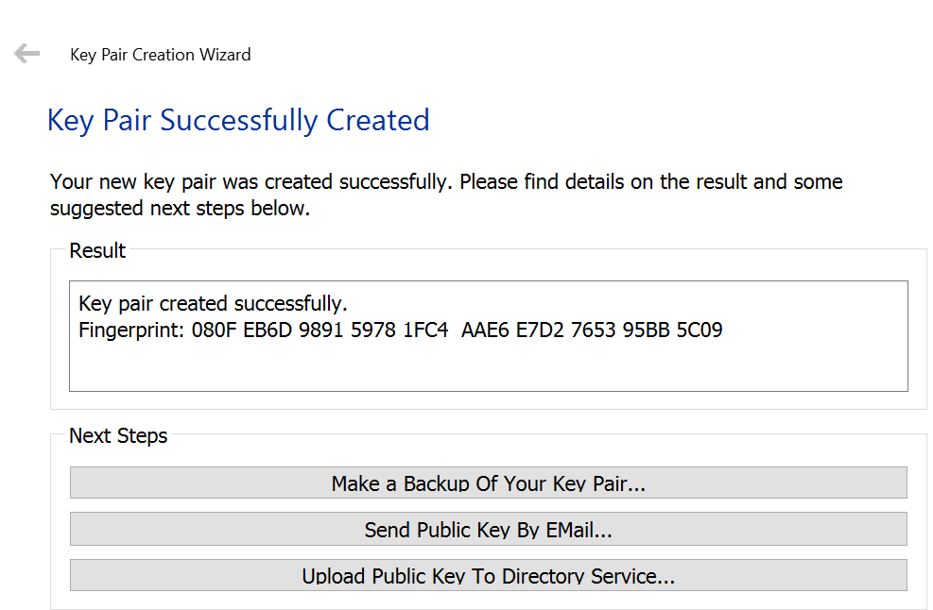

Sending public key

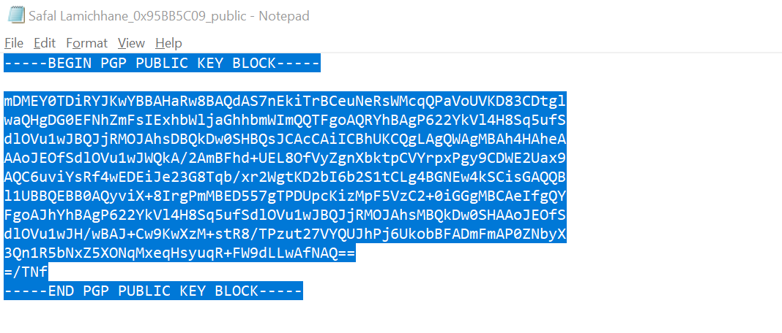



At first I will send the message using Nowsh Public key

This is nowsh public key

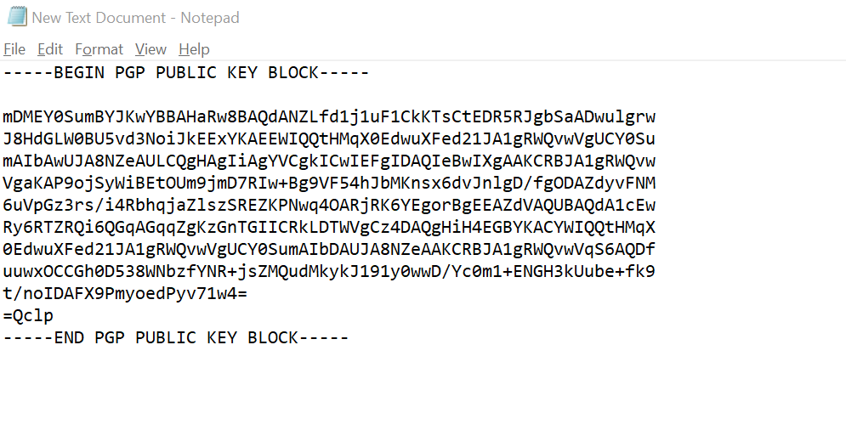

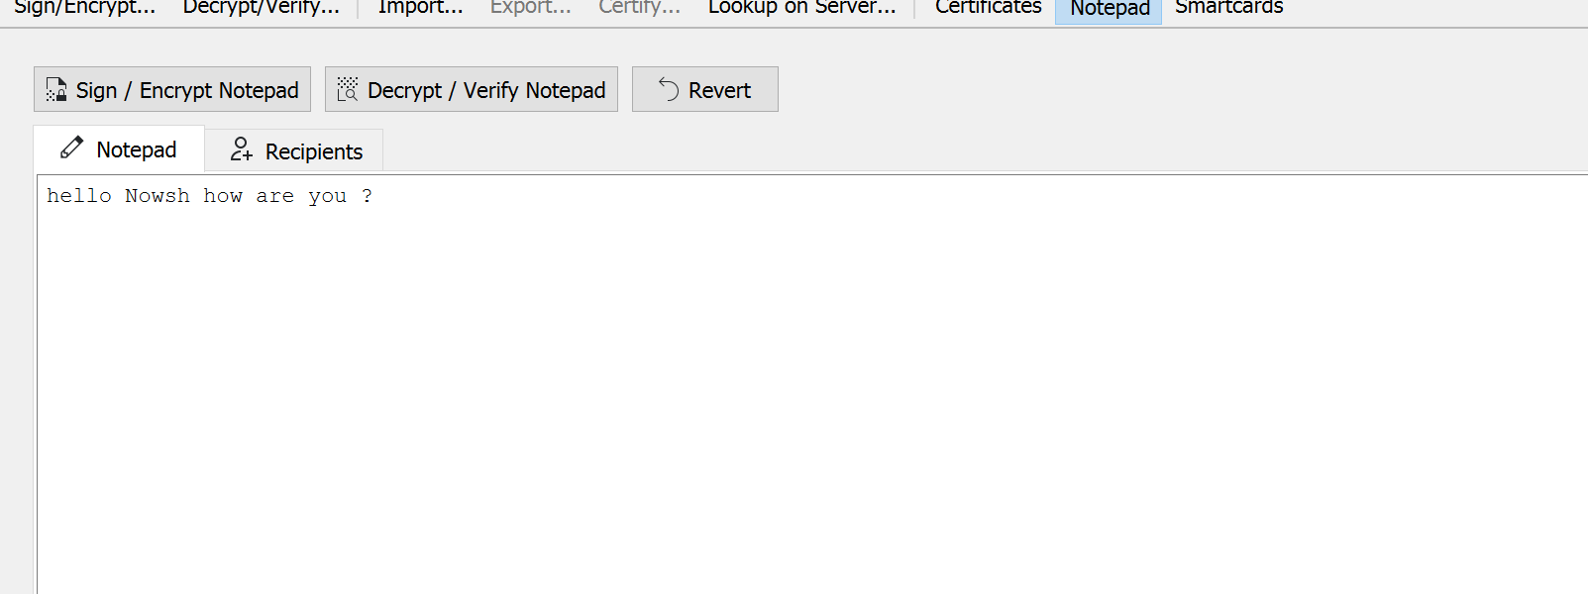

The message is now encrypted and I will send him the key

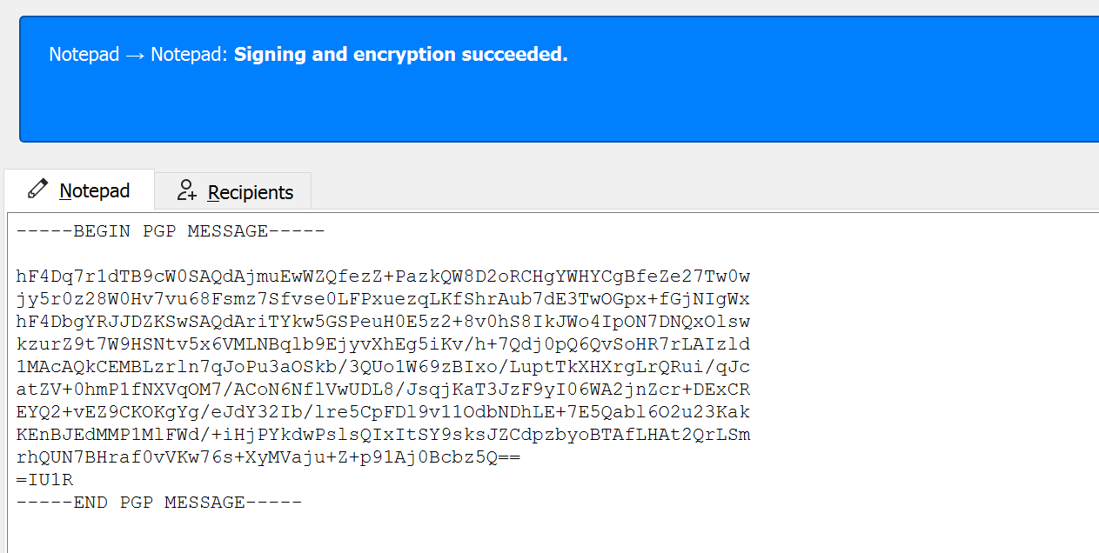

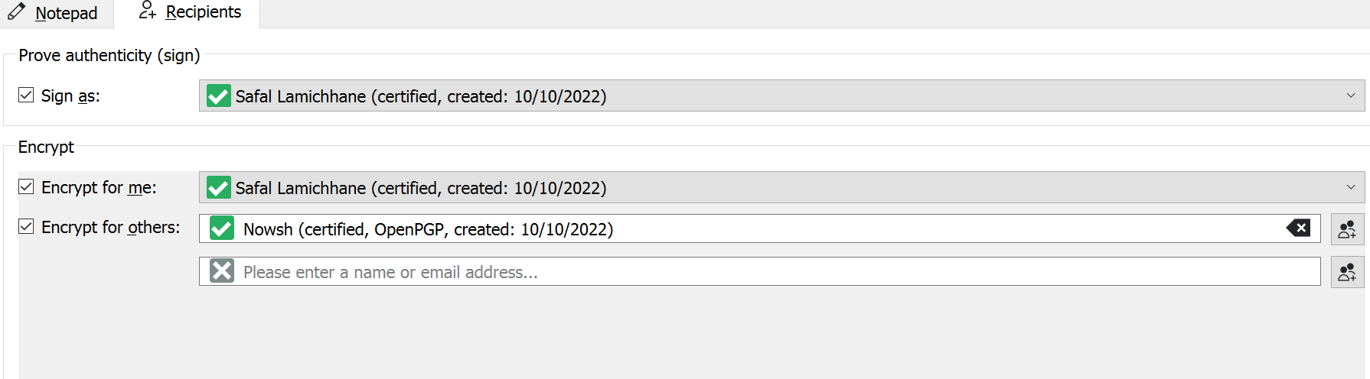

Now he will decrypt the message to get the plain text.

I had send him my public key, now nowsh will send the encrypted message and I will decrypt it using private key.



This is the message he sent it to him lets decrypt it

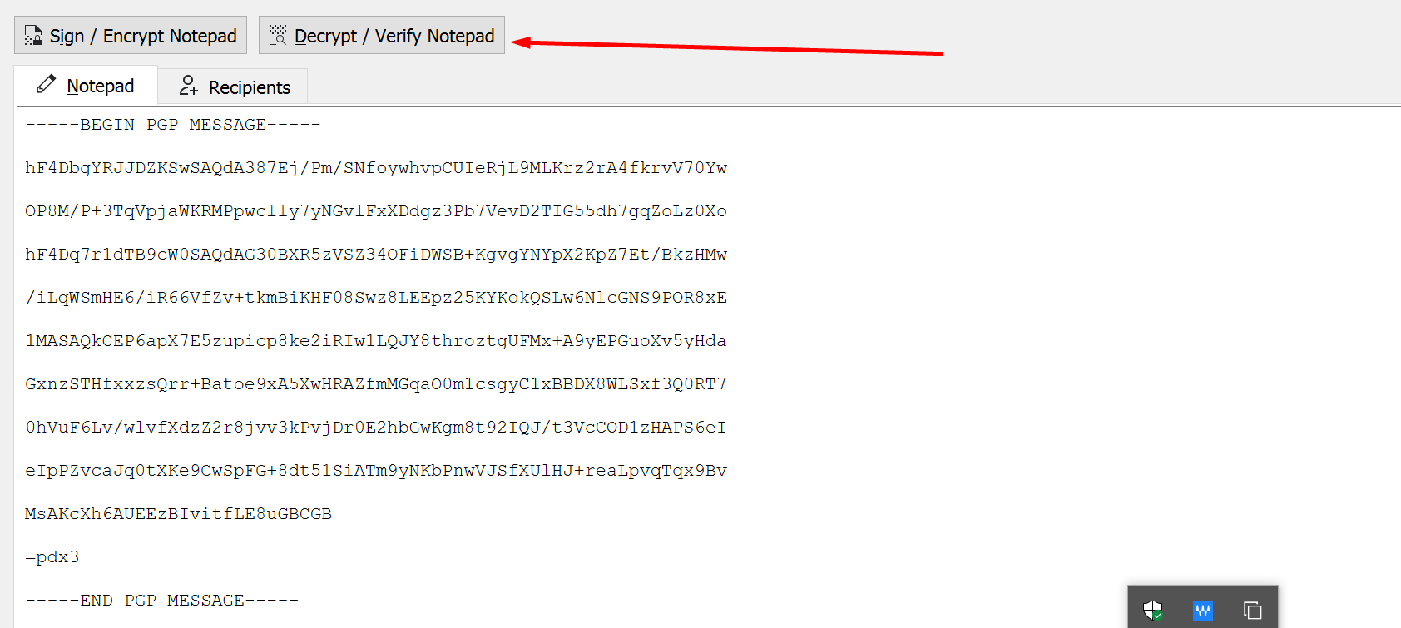

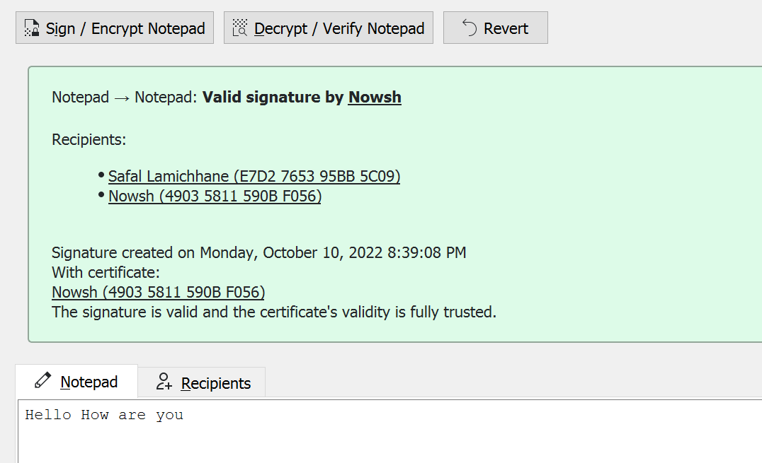

We can see the plaintext here.